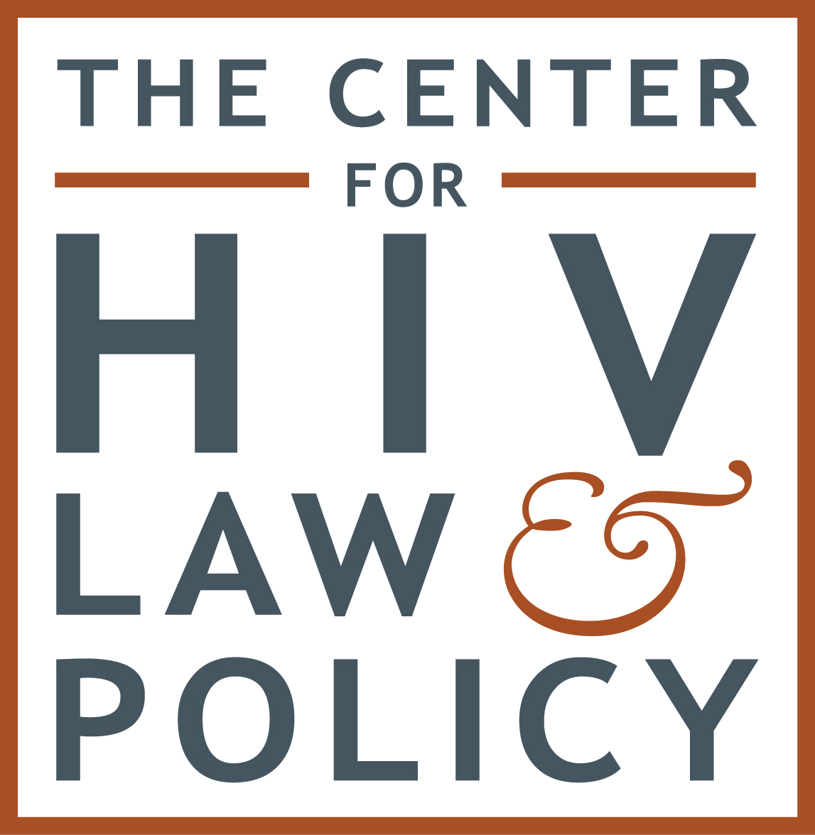

Testimony Before the New York City Council Committee on Education, Committee on Health, and Committee on Women’s Issues

On Student Health Services, Comprehensive Health Education, and Sexual Health Educational Training

Submitted by: Pepis Rodriguez
The Center for HIV Law and Policy
65 Broadway, Suite 832
New York, NY 10006
Phone: 212-430-6733
Email: jrodriguez@hivlawandpolicy.org
www.hivlawandpolicy.org

October 27, 2015

Good morning. Thank you, Chairman Dromm, Chairman Johnson, Chairwoman Cumbo, and members of the Committees for the opportunity to speak this morning. My name is Pepis Rodriguez, and I am pleased to offer this testimony on behalf of The Center for HIV Law and Policy (CHLP), a national legal and policy resource and advocacy center working to end HIV discrimination. I coordinate CHLP’s Teen SENSE initiative, which works to secure the rights of system-involved youth to comprehensive, LGBTQ-inclusive sexual health care and sexual health literacy programs. This includes ensuring that staff of foster care, detention, and other government-operated and –regulated youth facilities are trained to understand and respond to the needs of all youth in their care, regardless of sexual orientation, gender identity, gender expression, or HIV status. CHLP supports the Committees’ efforts to ensure transparency in the areas of “Student Health Services”, “Comprehensive Health Education”, and “Sexual Health Educational Training.” However, I must urge the Committees to expand such efforts to benefit all young people, particularly LGBTQ and system-involved youth. CHLP supports LGBTQ-inclusive sexual health care and literacy programs. Moreover, I urge the Committees to consider similar policies for the benefit of our youth under state care.
Increasing young people’s sexual health knowledge and ensuring access to sexual health services and programming are critical prevention strategies that can help stop sexual violence and promote healthy sexual attitudes and behaviors. The link between sexual health and safety is the foundation of our work in New York. As such, we have partnered with the Administration for Children’s Services (ACS) on several initiatives over the last few years. The need for dissemination of sexual health knowledge and access to sexual health services are all the more urgent for our youth living with HIV and our LGBTQ youth, who face additional hurdles because of their sexual orientation, gender identity, or gender expression. ACS acknowledges that as many as 82% of LGBTQ youth experience some form of mistreatment in the classroom. When we provide sexual health care and literacy programs that do not account for their specific needs, we are complicit in such mistreatment. If we marginalize LGBTQ youth and youth living with HIV, why wouldn’t their peers?
This is no less true for our youth in state care. Youth of color, youth from low-income backgrounds, LGBTQ youth, and youth survivors of sexual violence are significantly overrepresented in state custody settings. Youth entering the system often present with histories of physical abuse, sexual abuse, emotional abuse, neglect, and family instability. Sexually abused girls and young women are significantly more likely than their non-abused peers to enter care, and once there, often experience greater risk of sexual violence. For some, the pathway into state custody includes periods of homelessness and engaging in high-risk sexual behavior, often in exchange for shelter or food. Youth in out-of-home care face significant threats to their sexual health and well-being, including higher rates of sexually transmitted infections (STIs), HIV, unintended pregnancy, and substance abuse. For some youth who identify or are perceived as LGBTQ, their sexual orientation, gender identity, or gender expression may have led to family rejection, abuse, or neglect, prompting the state to remove them from their home.
A recent United States Department of Justice (DOJ) report surveying over 8,700 adjudicated youth in juvenile facilities across the United States found that nearly 10% of youth reported experiencing one or more incidents of sexual victimization by another youth or staff in the past 12 months or since admission, if less than 12 months. According to the DOJ report, LGBTQ youth were nearly seven times as likely to report youth-on-youth victimization as heterosexual youth. In light of this data, I urge the committees to review our Teen SENSE Model Policies and Standards on sexual health care for youth in state custody, endorsed by ACS, for implementation.
A New York City Council Resolution expressing the need for written policies guaranteeing comprehensive, LGBTQ-inclusive sexual and reproductive health services and programming to the youth in its care would provide this public policy issue the urgency and platform it deserves. The Committee on Education, the Committee on Health, and the Committee on Women’s Issues are each well suited to introduce a Resolution that will help ensure that all young people, including our LGBTQ youth and our system-involved youth, have access to the sexual health services, sexual health literacy programs, and supportive and adequately trained staff they need to be safe and to thrive. CHLP looks forward to working closely with the Committees on this important next step to protect and provide adequate services for all young people. Thank you.

http://www.nyc.gov/html/acs/html/lgbtq/lgbtq.shtml
Allen J. Beck, David Cantor, John Hartge & Time Smith, U.S. Dept. of Just., Off. of Just. Programs, Bureau of Statistics, Sexual Victimization in Juvenile Facilities Reported by Youth, 2012: National Survey of Youth in Custody, 2012 (2013), available at http://www.bjs.gov/content/pub/pdf/svjfry12.pdf (2013).
Id.
Teen SENSE Model Policy: Sexual Health Care for Youth in State Custody available at http://www.hivlawandpolicy.org/sites/www.hivlawandpolicy.org/files/Teen%20SENSE%20Model%20Policy%20-%20Sexual%20Health%20Care%20for%20Youth%20in%20State%20Custody.pdf. Teen SENSE Model Policy: Sexual Health Literacy for Youth in State Custody available at http://www.hivlawandpolicy.org/sites/www.hivlawandpolicy.org/files/Teen%20SENSE%20Model%20Policy%20-%20Sexual%20Health%20Literacy%20for%20Youth%20in%20State%20Custody.pdf. Teen SENSE Model Policy: Staff Training Focusing on the Needs of Youth in State Custody available at http://www.hivlawandpolicy.org/sites/www.hivlawandpolicy.org/files/Teen%20SENSE%20Model%20Policy%20-%20Staff%20Training%20Focusing%20on%20the%20Needs%20of%20Youth%20in%20State%20Custody.pdf. Teen SENSE Model Standards: Sexual Health Care for Youth in State Custody available at http://www.hivlawandpolicy.org/sites/www.hivlawandpolicy.org/files/Teen%20SENSE%20Model%20Standards%20-%20Sexual%20Health%20Care%20for%20Youth%20in%20State%20Custody.pdf. Teen SENSE Model Standards: Sexual Health Literacy for Youth in State Custody available at http://www.hivlawandpolicy.org/sites/www.hivlawandpolicy.org/files/Teen%20SENSE%20Model%20Standards%20-%20Sexual%20Health%20Literacy%20for%20Youth%20in%20State%20Custody.pdf. Teen SENSE Model Standards: Staff Training Focusing on the Needs of Youth in State Custody.

